SPACE SELF ASSESSMENT
NAME: _______________________________________________ GRADE: ____________________________
Self Space – a place all by yourself where you cannot touch anyone or anything.
General Space – all of the space in the whole room.
Here is a picture of the class. Draw a picture of yourself in your self-space:
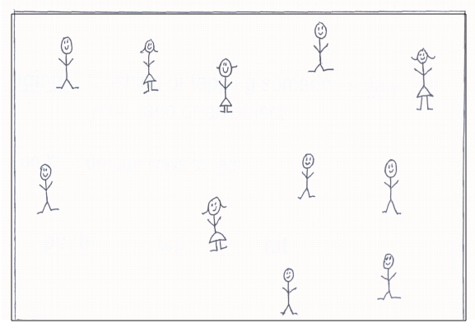

SPACE SELF ASSESSMENT
NAME: _______________________________________________ GRADE: ____________________________
Self Space – a place all by yourself where you cannot touch anyone or anything.
General Space – all of the space in the whole room.
Here is a picture of the class. Draw a picture of yourself in your self-space:

